QUANTITATIVE MODULE
Queuing Models

Discussion Questions
1. Three parts of a queuing system: arrivals or inputs to the
system; the queue discipline, or the waiting line itself; and the service facility.
2. Qualitative concerns include fairness and the aesthetics of the area in which waiting takes place.
3. Arrivals are governed by the size of the source population (finite or infinite); the pattern of arrivals at the system (on a schedule or randomly); and the behavior of the arrivals (joining the queue, balking, or reneging).
4. Measures of system performance:
- The average time each customer or object spends in the queue;
- The average queue length;
- The average time each customer or object spends in the
system;
- The average number of customers in the system;
- The probability that the service facility is idle;
- The utilization factor for the system;
- The probability of a specific number of customers or objects in the system.
5. Assumptions of the “basic” single channel model:
1. Arrivals are served on a first-come, first-served (FCFS)
basis, and every arrival waits to be served, regardless of the length of the line or queue.
2. Arrivals are independent of preceding arrivals, but the
arrival rate does not change over time.
3. Arrivals are described by a Poisson probability distribution and come from an infinite population.
4. Service times vary from one customer to the next and are
independent of one another, but their average rate is known.
5. Service times occur according to the negative exponential distribution.
6. The service rate is faster than the arrival rate.
6. This is, of course, how most supermarket bakeries operate—FCFS by the use of numbers. This is good because at the bakery, we cannot distinguish long jobs from short ones. (This can be compared with the situation at the checkout counter; where we can estimate job length according to the number of items being purchased by a customer in a particular line.)
7. “Balk” is to refuse to enter the queue: “renege” is to leave the queue (without being served) after entering. Examples of balk
come from observing “the line is too long” to “the line isn’t
moving very fast.” Renege examples may come from “the other line is moving faster” or “I can’t wait any longer.”
8. Ws is the time spent waiting plus being serviced, Wq is the time spent waiting for service. Ws is therefore larger than Wq by the amount of time spent on the service itself.
9. The first in, first out priority rule is often not valid. Examples of when other rules are more appropriate include:
- Hospital emergency room (most severely injured first)
- An elevator (last in, first out)
- Popcorn stand at a theater (random)
- Small store (he who yells loudest)
- Computer system (preassigned priority levels, highest level gets served first)
- Restaurant (service may be based on match between the number in your party and seats currently available)
- Grocery store (“general” checkout counters; self checkouts; counters for “10” or fewer items)
10. If λ > μ: Intuitively, the queue will grow progressively longer, because the arrival rate is larger than the service rate.
Analytically, the performance measures take on negative signs, which have no meaning, except as indicators of a queue with a serious problem.
11. If λ is only slightly smaller than μ: The denominator of the performance measures all include (μ − λ). This value is now very small, making the performance measures large. Average number of objects in the system grows large, as does the average time spent waiting.
12. Finite waiting lines exist in:
- Barber shops (there are only a limited number of seats for waiting because of space)
- A company that has five telephone receivers connected to a single incoming line (multichannel, zero-length waiting line)
- A company that has five lines coming to a single telephone receiver (single-channel, waiting line of maximum length five)
- Gasoline station where cars lining up for gas are restricted to a particular, finite parking area (they cannot continue the line into the street, for example)
- Persons leaving an elevator
Finite sources exist when:
- A company has only three or four machines that may need service
- A small airport that has only 10 or 15 flights scheduled each day
- A maximum of 30 students are due to arrive at a classroom
- A hospital ward has only 10 patients who may need a particular type of care today
13. Barber shop:
Arrivals → Customers wanting haircuts
Waiting line → Seated customers; limited number of chairs; priority is informal FIFO
Service → Haircut, shampoo, etc. For simple service, single phase; for more complex service sequence (shampoo, haircut, manicure, etc.), probably multiphase
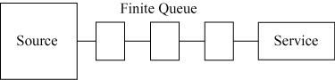
Car wash: Usually either a single-channel, single-server system; a system with each service bay having its own queue; or a self-service system.
Single channel:
Arrivals → Dirty cars
Waiting line → Cars in single line
Service → Single phase (all automatic wash), or multiphase (vacuum, soap, wash, dry, polish, each performed by a separate worker or crew) (Note that we term this a single-service facility even though work may be performed by several individuals or crews.)
Single phase:
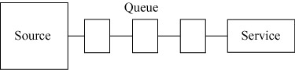
Multiphase:
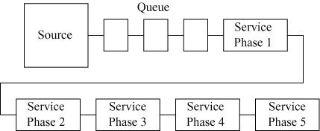
Multichannel, single phase:
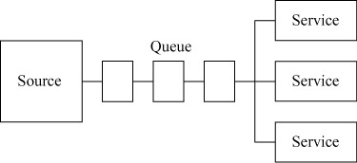
Note: In practice, it is often difficult to differentiate between a multichannel system, and a system that has multiple, parallel, service facilities, but that actually operates as several separate single-channel systems. Usually, if we have a system with m parallel service facilities, and a single line forms within the boundary of the system, then we consider the system to be a multichannel system. If, on the other hand, a line forms within the system ahead of
each of the m parallel service facilities, we consider the system as if it
were m separate single-channel systems, each with an arrival rate equal to the original arrival rate divided by m.
Laundromat:
Arrivals → Customers with loads of dirty laundry
Waiting line → Customers waiting in a group for the next available washing machine or drier. Service on an informal FIFO
priority basis.
Service facility → Two-phase system (washer, drier); each phase multichannel.
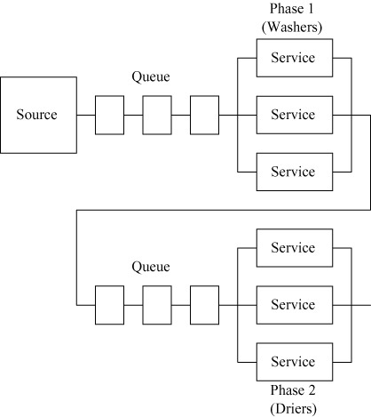

Note: Queues can be affected by customers who wash only, or
dry only.
Small grocery store:
Usually a two-phase system: first phase, self-service (an infinite number of channels); second phase, single channel
Arrivals → Customers to purchase food items
Waiting line →
Phase 1: no line
Phase 2: customers with cart or basket of groceries arrive at cash register. Usually FIFO, but grocer may check out regular customers first, or give priority to customer making a small, quick, purchase
Service →
Phase 1: gathering groceries; self-service
Phase 2: ring up sale, give change, bag groceries
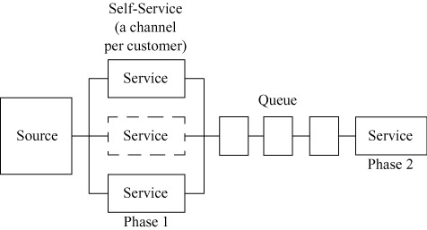

14. Doctor’s offices generally attempt to schedule “group” arrivals (10 patients on the hour, every hour), or uniform arrivals (1 patient every 15 minutes). Arrivals at an emergency center, on the other hand, are typically Poisson.
Service times often random, and described by either a negative exponential or normal probability distribution.
Service times would approach a constant only when the physician provided approximately the same treatment to each patient. This might occur in the case of physical exams, or a clinic providing flu shots.
15. Constant service time model will have an average queue length and an average waiting time that is one-half that of the same model with exponential service time.
16. This deals with the interesting issue of the value of waiting time. Some service organizations place a very low value on your time, leading to a good classroom discussion.
17. Little’s Law is useful because it makes it easy to find a third parameter if two are already computed/known. The law makes no assumptions about probability distributions, number of servers, or priority rules.
Active Model Exercises*
Active Model D.1: Single Server Model
1. For how many minutes do customers wait before their muffler installation begins?
40
2. How fast would the average installation (service) time have to be to cut the waiting time in half?
16 minutes
3. Suppose the arrival rate increases by 10 percent to 2.2 customers per hour. By what percentage will the waiting time rise?
37.5%—From 40 to 55
4. What is the probability that there is no waiting line when a car arrives for service?
There is no waiting line if no one is in the system or if one person is in the system. From the graph, the respective probabilities are .33 and .22, for a total of 55%.
5. What happens to the probabilities as the arrival rate increases?
The probabilities of low numbers of customers in the
system fall while the probabilities of high number of customers in the system rises.
Active Model D.2: Multiple Server System with Costs
1. What number of mechanics yields the lowest total daily cost? What is the minimum total daily cost?
2 mechanics; $112 + 6.67 = $118.67
2. Use the scrollbar on the arrival rate. What would the arrival rate need to be in order that a third mechanic would be required?
3.8 cars per hour
3. Use the scrollbar on the goodwill cost and determine the range of goodwill costs for which you would have exactly one mechanic? two mechanics?
For a goodwill cost of less than $5 per hour, use 1 mechanic. Two mechanics would be best for a goodwill cost anywhere between $5 per hour and $100 per hour.
4. How high would the wage rate need to be in order to make 1 mechanic the least costly option?
From the graph—roughly $12.70
*Note that Active Models D.1-D.3 appear on our Web sites,
www.pearsonhighered.com/heizer and www.myomlab.com.
5. If a second mechanic is added, is it less costly to have the two mechanics working separately or to have the two mechanics work as a single team with a service rate that is twice as fast?
Separately—$118.67; together—changing the service rate to 6 and doubling the wages, the single server cost is $112 + $13.33, or $125.33. Therefore, having them work separately is less costly.
Active Model D.3: Constant Service Times
1. The arrival rate of trucks is, of course, a forecast and therefore uncertain. What is the break-even point, in truck arrivals per hour, between keeping the old compactor and purchasing the new one?
At 10 trucks per hour or higher, we should not purchase the new compactor.
2. The service rate represents, of course, the design capacity. What minimum rate is needed in order to save money with the purchase of a new compactor?
10 trucks per hour or more.
End-of-Module Problems
D.1 This is an M/M/1 queue; λ = 3/hr; and μ = 5/hr.
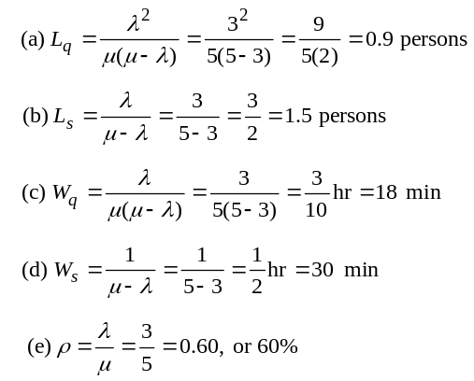
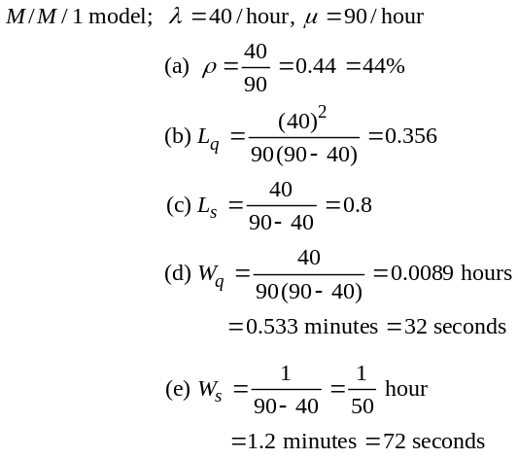

D.2

D.3
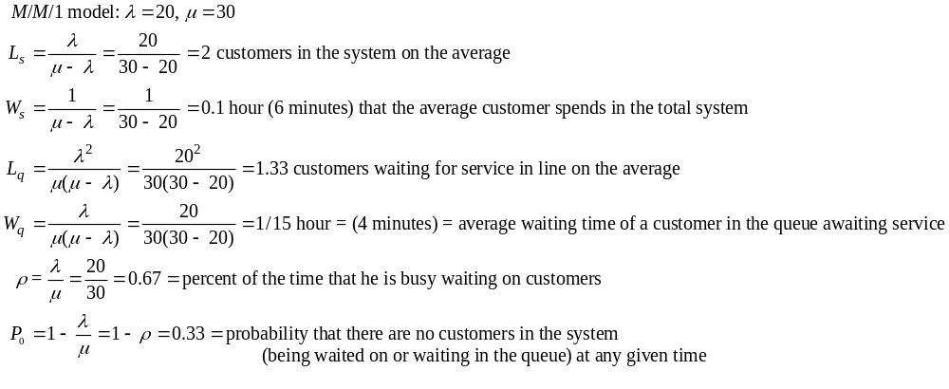

Probability of k or More Customers
Waiting in Line and/or Being
Waited On
 | k | 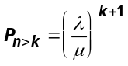
 | 0 | 0.667
 | 1 | 0.444
 | 2 | 0.296
 | 3 | 0.198

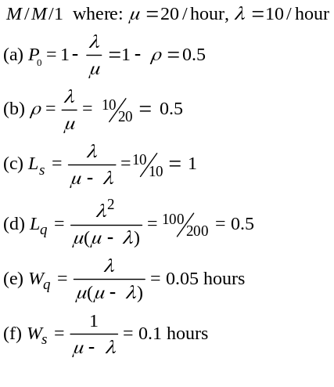
M/M/1 model: λ = 12, μ = 15
(a) Lq = Average number of prescriptions in the queue:
From Table D.5, ρ = .8,
So Lq = 3.2
(b) Wq = Average time a prescription spends in the queue:
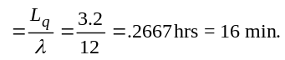
(c) Using M = 2 in Table D.5, ρ = .8, so
Lq = .1523
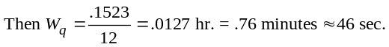

D.5

D.6
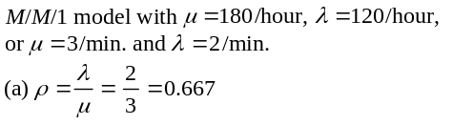
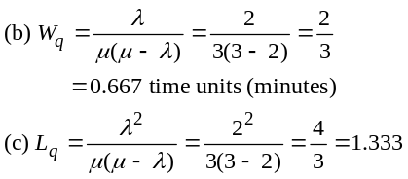
D.7 This is an M/M/1 model. λ = 24, μ = 30
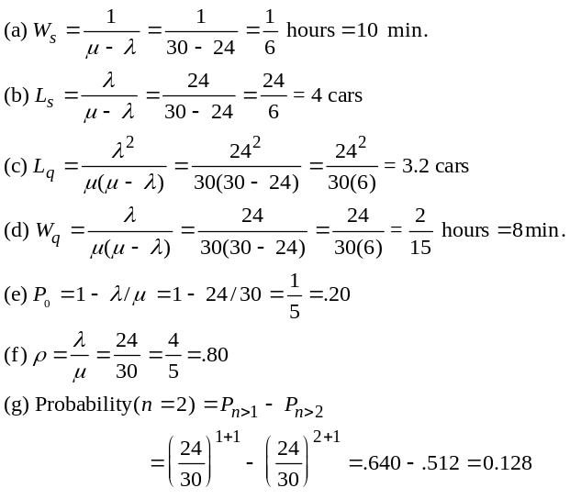
(h) With a second server at the same μ = 30 speed,  = .04 hours
= 2.38 minutes
D.8 M/M/1 model with λ = 3, μ = 8
(a) The utilization rate, ρ, is given by:
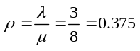
(b) The average down time, Ws, is the time the machine waits to be serviced plus the time taken to perform the service.
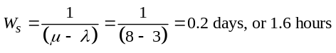

D.4

(c) The number of machines waiting to be served, Lq, is, on average:
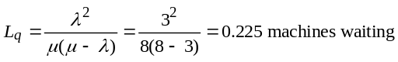
(d) Probability that more than one machine is in the system:
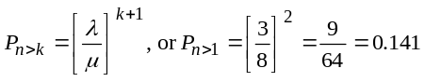
Probability that more than 2, 3, 4 machines are in the system:
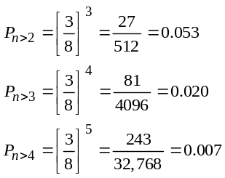
D.9 This is an M/M/1 model; λ = 10, μ = 15
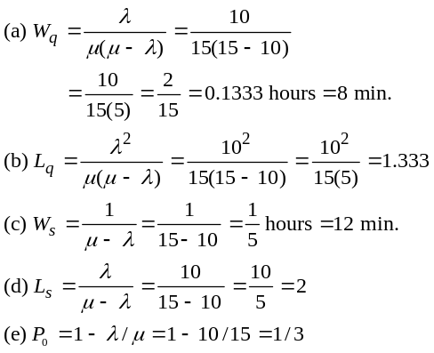
(f ) This is an M/M/2 model; λ = 10, μ = 15
(a) Wq = 0.0083 hours
(b) Lq = 0.0833
(c) Ws = 0.075 hours
(d) Ls = 0.75
(e) P0 = 0.5
D.10 M/M/1 λ = 210 patrons/hour, μ = 280 patrons/hour; M/M/1 model
(a) The average number of patrons waiting in line, Lq, is given by:
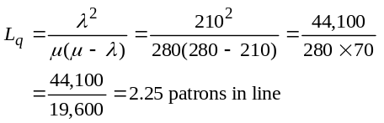
(b) The average fraction of time the cashier is busy, ρ, is given by:
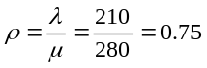

(c) The average time a customer spends in the ticket
dispensing system, Ws, is given by:
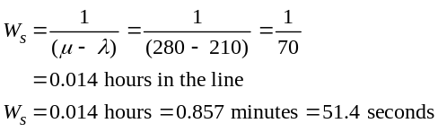
(d) The average time spent by a patron waiting in line to get a ticket, Wq, is given by:
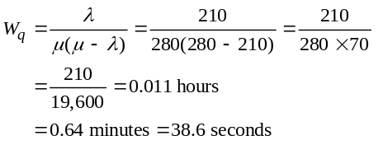
(e) The probability that there are more than two people in the system, Pn>2, is given by:
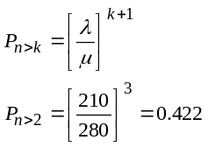
The probability that there are more than three people in the system, Pn>3, is given by:
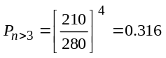
The probability that there are more than four people in the system, Pn>4, is given by:
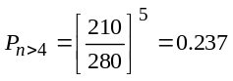
D.11 This is an M/M/1 queue; λ = 25/hr.; and μ = 30/hr.
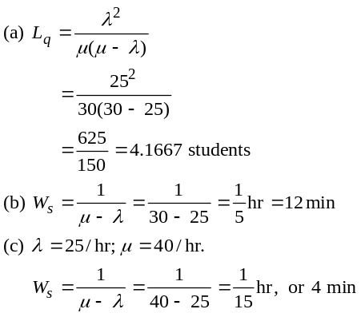
The new time is 4 min, a reduction of 8 min.
(d) This is an M/M/2 queue; λ = 25; μ = 30.
Ws = 0.04 hr, or 2.4 min
D.12 M/M/1 λ = 30 trucks/hour, μ = 35 trucks/hour; M/M/1 model
(a) The average number of trucks in the system, Ls, is given by:
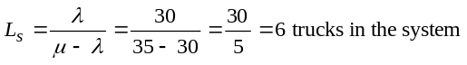
(b) The average time spent by a truck in the system, Ws, is given by:
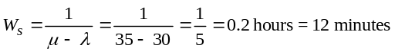
(c) The utilization rate for the bin area, ρ, is given by:
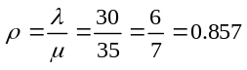
(d) The probability that there are more than three trucks in the system, Pn > 3, is given by:
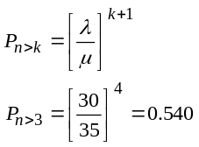
Thus, the probability that there are more than three trucks in the system is 0.540.
(e) Unloading cost:
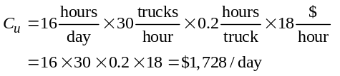
or $12,096 per week
(f ) Enlarging the bin will cut waiting costs by 50% next year. First, we must compute annual waiting costs:
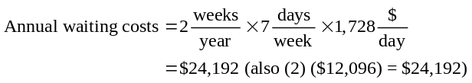
Enlarging the bin will cut waiting costs by 50% next year, resulting in a savings of $12,096. Because the cost of enlarging the bin is only $9,000, the cooperative should proceed to enlarge the bin. The net savings is $3,096 (= 12,096 – 9,000).
D.13 M/M/1 Model: λ = 12 calls/hour, μ = 60/4 = 15 calls/hour
(a) The average time the catalogue customer must wait, Wq, is given by:
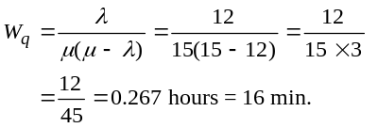
(b) The average number of callers waiting to place an
order, Lq, is given by:
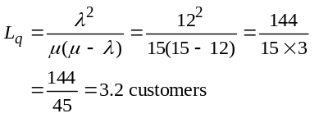
(c) To decide whether or not to add the second clerk,
we must:
- Compute present total cost
- Compute total cost with the second clerk
- Compare the two
Present total cost:
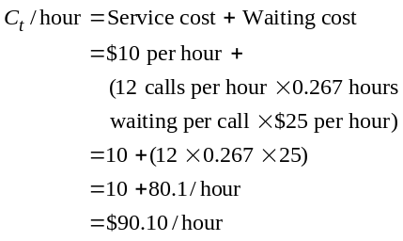
To determine total cost using the second clerk (a second channel):
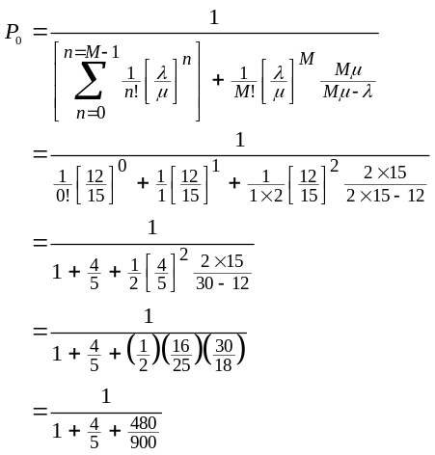
or:
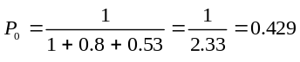
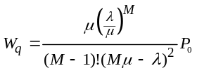
Then:
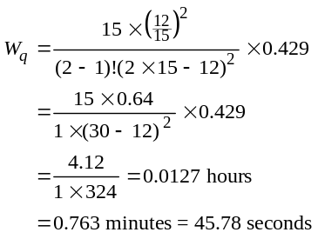
Or: 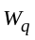 =  – = 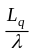
L_{q} = .1523 from Table D.5 with
P = .8 and M = 2
So = 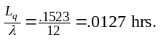
Cost with two clerks:
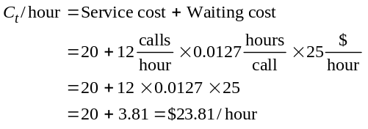
There is a saving of $90.10 –$23.81 = $66.29/hour
Thus, a second clerk should certainly be added!
With three clerks the cost goes to $30.47. So the costs are:
1 clerk $90.10
2 clerks $23.81
3 clerks $30.47
For 3 clerks, Wq = 0.00158 (from Excel OM)
$30 + (12 × 0.0015 × $25) = $30 + 0.47 = $30.47
Therefore, optimum number of clerks is 2.
D.14 λ = 15/hour, μ = 20/hour
(a) Wq = 0.075 hours = 4.5 minutes
(b) Lq = 1.125 people
(c) Now λ = 10/hour, μ = 30/hour: So,
Wq = 0.0083 hours = minute = 30 sec.
Lq = 0.083 people
D.15 (a) Entering: λ = 84/minute, μ = 30/minute, ρ = 2.8
Exiting: λ = 48/minute, μ = 30/minute, ρ = 1.6
The manager desires that Wq ≤ 0.1 minute = 6 seconds and that Lq ≤ 8 customers in queue.
Entering:
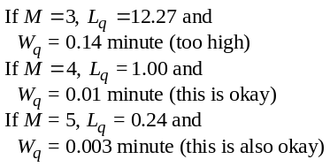
So the manager must open M = 4 or more entrances.
Exiting:
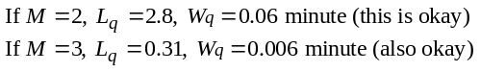
So the manager must open M = 2 or more exits. Since there are only 6 turnstiles, 4 must be used as entrances and 2 as exits.
(b) The students should recognize and question all the limiting queuing assumptions that have been applied in solving the case. For example, it may be reasonable to assume that arrivals at the entrance turnstiles are independent and Poisson. But are exiting passengers independent? More realistically, they arrive in batches (as a train arrives), and unless trains unload every minute or two, this assumption may be unreasonable.
Other problems arise as well. If an exiting passenger’s card does not have the correct fare, the card is rejected and the passenger must leave the line, go to an “add fare” machine to correct the deficiency, and enter the queue again. This resembles the reneging customer.
Note: In the real-world subway station in Washington, DC, common queues are not formed at turnstiles and the problem becomes a series of single channel queues.
D.16 λ = 10/hour, μ = 60/4.5 = 13.33/hour; M/D/1 model
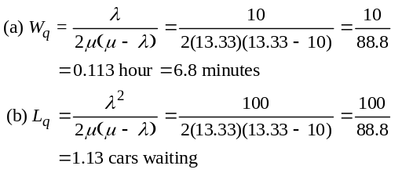
D.17 Model D: N = 5 tools
M = 1 technician
T = 2 hours/8 hour day =day
U = day
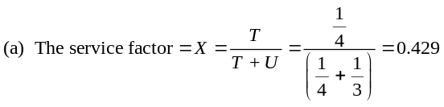
(which is close to 0.420 for Table D.8); F = .471
(b) Average no. of machines in service (using Table D.7) =
J = NF(1 – X) = 5(0.471) (1 – 0.429) = 1.34
(c) With M = 2 technicians, F rises to 0.826. The average number of machines in service grows to J = 5(0.826)
(1 – 0.429) = 2.36
D.18 Model D N = 5 computers, M = 2 technicians, T = 15 minutes, U = 85 minutes
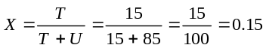
(a) The average number of computers waiting for service, L, is given by:
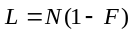
where F is found from Table D.8. From Table D.8, with M = 2, X = 0.15: F = 0.990
(b) The average number of computers being served, H, is given by:
H = FNX
where F is found from Table D.8. From Table D.8 with M = 2, X = 0.15: F = 0.990
H = 0.990 × 5 × 0.15 = 0.743 computers
(c) The average number of computers not working is given by:
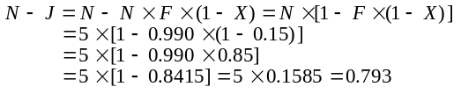

Therefore, on average, 0.793 computers are not work-ing properly.
D.19 Model D N = 5 drilling machines, M = 1 mechanic, T = 1 day, U = 6 days
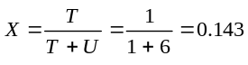
The value 0.145 will be used for X when referencing Table D.8.
(a) The average number of machines waiting for service, L, is given by:
L = N(1 – F)
where F is found from Table D.8. From Table D.8, when M = 1, X = 0.145; F = 0.892
L = 5(1 – 0.892) = 0.54 machines waiting
(b) The average number of machines in running order, J, is given by: J = NF(1 – X) where F is found from Table D.8. From Table D.8, with M = 1, X = 0.145; F = 0.892
J = 5 × 0.892 × (1 – 0.145) = 3.81 machines
(c) The reduction in waiting time obtained by employing a second mechanic is found as follows: Waiting time employing a single mechanic, W1, is given by:
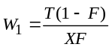
where F is found from Table D.8. From Table D.8, when M = 1, X = 0.145; F = 0.892.
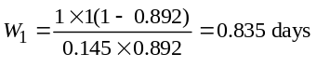
From Table D.8, with M = 2, X = 0.145: F = 0.991
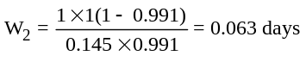
The time saved is given by: W1 – W2
Time saved = 0.835 – 0.063 = 0.772 days6 hours for an 8-hour day
D.20 (a) M/M/S 9 a.m.–3 p.m.: Arrival rate = 6 patients/hour
Service rate = 5 patients/hour
Number of Doctors | Wait Time (minutes)
1
2 | 6.75
3 | 0.94
4 | 0.16
Therefore, three doctors are needed between 9 a.m. and 3 p.m.
3 p.m.–8 p.m.: Arrival rate = 4 patients/hour
Service rate = 5 patients/hour
Number of Doctors | Wait Time (minutes)
1 | 48.0
2 | 2.29
3 | 0.28
4 | 0.04
Therefore, two doctors are sufficient between 3 p.m. and 8 p.m.

8 p.m.–Midnight: Arrival rate = 12 patients/hour
Service rate = 5 patients/hour
Number of Doctors | Wait Time (minutes)
1
2
3 | 12.940
4 | 2.154
Therefore, four doctors are required between 8 p.m. and midnight.
(b) If only one doctor was on duty between 9 a.m. and 3 p.m., the line would back up indefinitely. This is because λ > μ.
D.21 Employee system: The current system is actually an M/D/1
system because service times are constant. λ = 10, μ = 12.
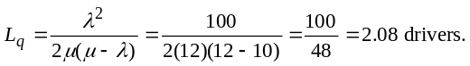(a)
The average number of drivers waiting to pay the toll is 2.08
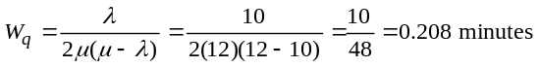(b) 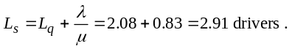The average number of drivers at any one toll booth is 2.91.
(c)

= 12.5 seconds. The average time drivers spend
waiting is 12.5 seconds.
(d) W_{s} = Waiting time + Service time = 12.5 seconds +
5 seconds = 17.5 seconds (or .29 minutes)
Automated system: The proposed system, although automated, is an M/M/1 system.
or using +
= .208 + 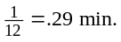
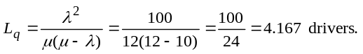
(a)

Twice as many drivers are in line under the new, automated system.
(b) 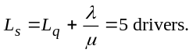On average, 5 customers are in the system, which is 67 percent more customers than
the current system allows.
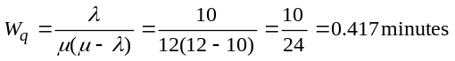(c)

= 25 seconds. The waiting time will double with the new system.
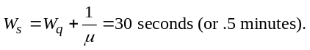(d)
The time in the system will rise by 67 percent. The employee system seems to be better overall.
D.22 M/M/S Model:
(a) Each server handles 60 registrants/hour, so it takes 4 servers to handle 200 arrivals/hour
(b, c) λ = 200, μ = 60
M = 4 servers yields: L_{q} = 3.29,
Server cost = 4 × $15 = $60
Wait cost = (3.29 people)($100) = $329 (rounded)
Total cost = $389
With M = 5 servers, L_{q} = 0.65,
Wait cost = (0.65)($100) = $65; Server cost = 5 × 15 = $75
Total Cost = $140
With M = 6 servers, L_{q} = .19
Wait cost = (.19)($100) = $19; Server cost = 6 × 15 = $90
Total cost = $109
With M = 7 servers, L_{q} = .06
Wait cost = (0.6)($100) = $6, Server cost = 7 × 15 = $105
Total cost = $111
So M = 6 servers is optimal, at a total cost
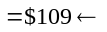 lowest cost
(d) Server utilization rate = 83.33% for 4 servers.
D.23 (a, b) λ = 200, μ = 60 again, as in Problem D.22.
Server costs do not change.
M = 6 servers is again optimal, at we see below:
For M = 4, (3.29)($50) = $164.50 = Wait cost
Total cost = $60 + $15 + $164.50 = $239.50
For M = 5, (.65)($50) = $32.50 = Wait cost
Total cost = $75 + $15 +$32.50 = $122.50
For M = 6, (.19)($50) = $9.50 = Wait cost
Total cost = $90 + $15 +$9.50 = $114.50
← lowest cost
For M = 7, (.06)($50) = $3 = Wait cost
Total cost = $105 + $15 + $3 = $123

D.24 | The manager’s calculations are as follows:
 |  | Number of Salespeople
 |  | 1 |  | 2 |  | 3 |  |  | 4
 | (a) Average number of customers per shift | 50 |  | 50 |  | 50 |  |  | 50
 | (b) Average waiting time per customer (minutes) | 7 |  | 4 |  | 3 |  |  | 2
 | (c) Total waiting time per shift (a × b) (minutes) | 350 |  | 200 |  | 150 |  |  | 100
 | (d) Cost per minute of waiting time (estimated) | $1.00 |  | $1.00 |  | $1.00 |  |  | $1.00
 | (e) Value of lost time (c × d) per shift | $350 |  | $200 |  | $150 |  |  | $100
 | (f ) Salary cost per shift | $70 |  | $140 |  | $210 |  |  | $280
 | (g) Total cost per shift | $420 |  | $340 |  | $360 |  |  | $380

Because the minimum total cost per shift relates to two salespeople, the manager’s optimum strategy is to hire two salespeople.

Additional Homework Problems
Here are solutions to additional homework problems on our that one web site (www.pearsonglobaleditions.com/myomlab).
D.25 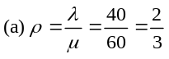
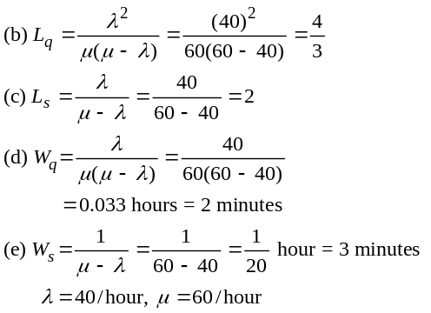
D.26 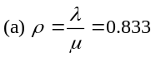
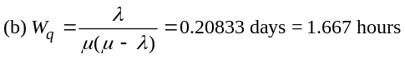
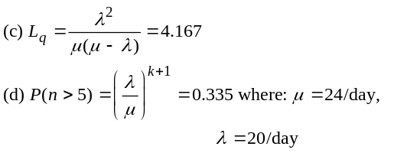
D.27 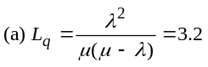
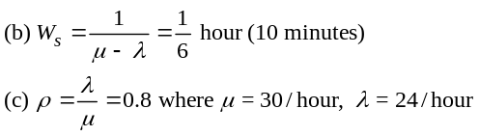
D.28 λ = 20 cars/hour, μ = 30 cars/hour
(a) The average number of cars in line Lq, is given by:
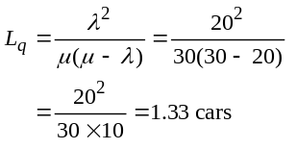
(b) The average time a car waits before it is washed, Wq is given by:
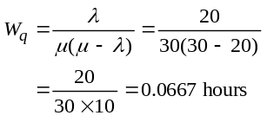
(c) The average time a car spends in the service system, Ws is given by:
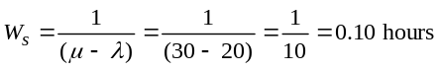
(d) The utilization rate, ρ, is given by:
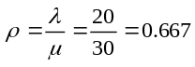
(e) The probability that no cars are in the system, P0, is given by:
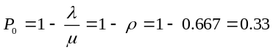
(f) Use of automation (with μ = 60/hour) will produce the following.
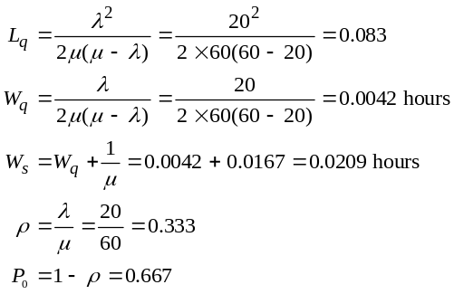
D.29 λ = 4, students/minute, μ = 60/12 = 5 students/minute
(a) The probability of more than two students in the
system, Pn > 2, is given by:
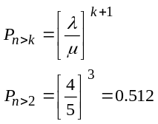
The probability of more than three students in the system, Pn > 3, is given by:
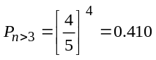
The probability of more than four students in the
system, Pn > 4, is given by:
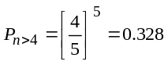
(b) The probability that the system is empty, P0, is given by:
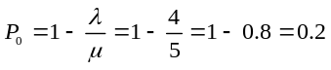
(c) The average waiting time, Wq, is given by:
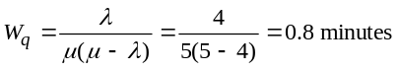
(d) The expected number of students in the queue, Lq, is given by:
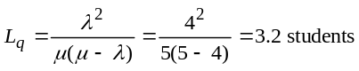
(e) The average number of students in the system, Ls is given as:
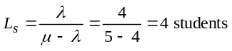
(f) Adding a second channel, we have:
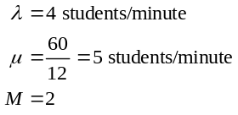
(b)′ The probability that the two channel system is empty, P0, is given by:
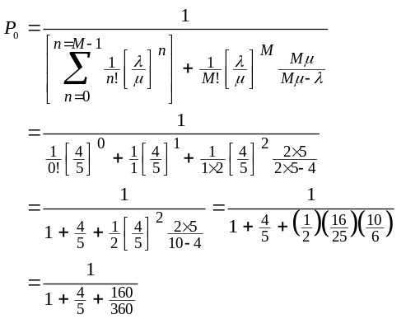
or:
Thus, the probability of an empty system when using the second channel, is 0.429.
(c)′ The average waiting time, Wq, for the two channel
system is given by:
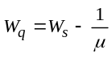
where:
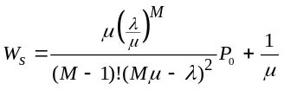
Then:
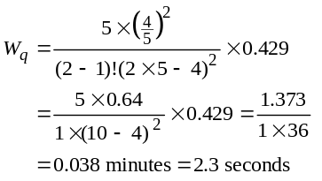
(d)′ The average number of students in the queue for the two channel system, Lq, is given by:
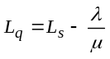
where:
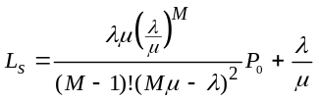
Then:
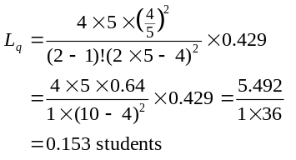
(e)′ The average number of students in the two channel system, Ls, is given by:
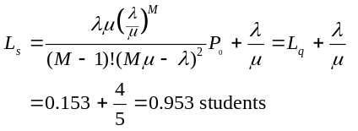
D.30 λ = 12/hour, μ = 60/15 = 4/hour, M = 4
(a) The probability that the shop is empty, P0, is given by:
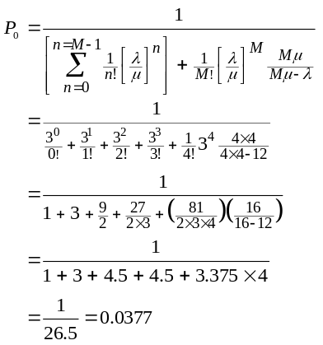
Therefore, the probability that the shop is empty is 0.0377.
(b) The average number of customers in the shop, waiting or getting served, Ls, is given by:
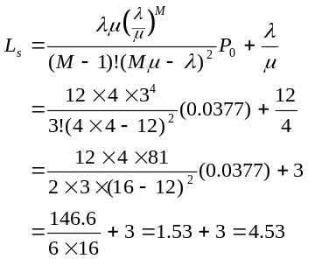
There are, on average, 4.53 persons in the shop.
(c) The average time spent in the shop, Ws, is given by:
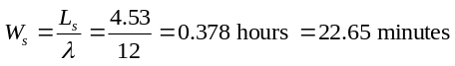
(d) The average time the customer spends waiting to be called, Wq, is given by:
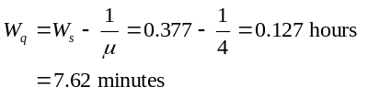
Therefore, the average customer waits 0.127 hours or 7.62 minutes.
(e) The average number of customers waiting to be served, Lq, is given by:
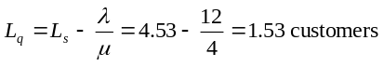
(f) The probability the system is empty with five barbers is found by:
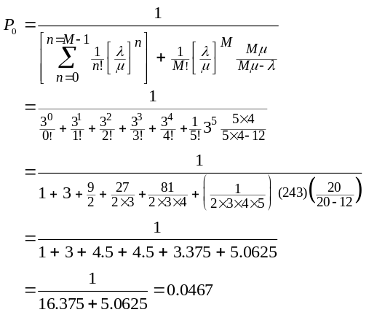
The utilization rate will be 1 – 0.0467 = 0.9533.

D.31 |  | Number of Checkpoint Clerks
 |  | 1 | 2 | 3 | 4
 | Number of customers | 300 | 300 | 300 | 300
 | Average waiting time | 1/6 hour | 1/10 hour | 1/15 hour | 1/20 hour
 |  | (10 minutes) | (6 minutes) | (4 minutes) | (3 minutes)
 | Total customer waiting time | 50 hours | 30 hours | 20 hours | 15 hours
 | Cost per waiting hour | $5 | $5 | $5 | $5
 | Total waiting costs | $250 | $150 | $100 | $75
 | Checkout clerk hourly salary | $4 | $4 | $4 | $4
 | Total pay of clerks for 8-hour shift | $32 | $64 | $96 | $128
 | Total expected costs | $282 | $214 | $196 | $203
Total cost is minimized by having three clerks on duty.

D.32 λ = cars/hour, μ = 12 cars/hour.
(a) The average number of cars in line, Lq, is given by
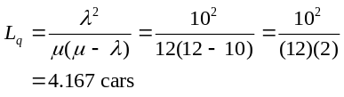
(b) The average time a car waits before it is washed, Wq, is given by
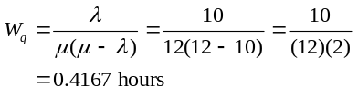
(c) The average time a car spends in the service system, Ws, is given by
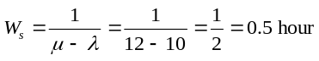
(d) The utilization rate, ρ, is given by
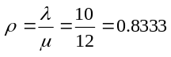
(e) The probability that no cars are in the system, P0, is given by:
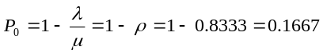

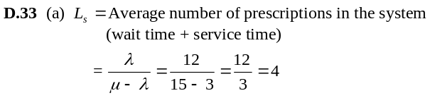
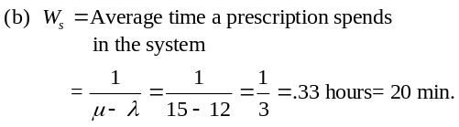
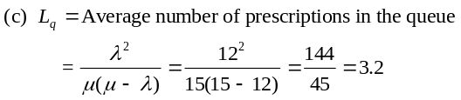

Case Studies
NEW ENGLAND FOUNDRY
1
1. How much time would the new layout save?
To determine how much time the new layout would save, the present system must be compared to the new system. The amount of time that an employee spends traveling to the maintenance department added to the time he spends in the system being serviced and waiting for service presently, compared to this value under the proposed system, will give the savings in time.
Under the present system, there are two service channels with a single line (M = 2). The number of arrivals per hour is 7(λ = 7). The number of employees that can be serviced in an hour by each channel is 5 (μ = 5). The average time that a person spends in the system is:
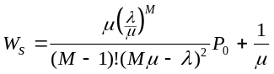
The average time a person spends in the system under the present system is 0.392 hours, or 23.5 minutes.
Adding the “system time” to the travel times involved
(6 minutes total for casting personnel and 2 minutes for molding personnel), the total trip takes:
for casting: 29.5 minutes
for molding: 25.5 minutes
Under the new system, waiting lines are converted to single-channel, single-line operations. Bob will serve the casting personnel and Pete will serve the molding personnel.
Bob can now service 6 people per hour (μ = 6). Four people arrive from the casting department every hour (λ = 4).
The time spent in Bob’s department is:
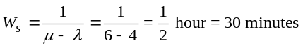
The reduced travel time is equal to 2 minutes, making the total trip time equal to 32 minutes. This is an increase in time of 2 minutes and 30 seconds for the maintenance personnel.
Pete can now service 7 people per hour (μ = 7). Three people arrive from the molding department every hour (λ = 3).
The time in Pete’s department is:
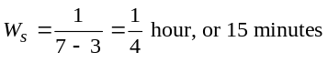
The travel time is equal to 2 minutes, making the total trip time equal to 17 minutes. This is a decrease in time of 8 minutes and
30 seconds per trip for the molding personnel.
2. If casting personnel were paid $9.50 per hour and molding personnel were paid $11.75 per hour, how much could be saved per hour with the new factory layout?
To evaluate systemwide savings, the times must be monetized. For the casting personnel who are paid $9.50 per hour, the 2.5 minutes lost per trip costs the company $0.40 per trip (2.5 ÷ 60 = 0.042 of an hour; 0.042 × 9.50 = 0.40). For the molding personnel who are paid $11.75 per hour, the 8 minutes and 30 seconds saved per trip saves in monetary terms $1.66 per trip. The net savings is $1.26 per trip.
Hourly savings:
On average there are 4 arrivals per hour from casting, and 3 arrivals per hour from the molding department. Therefore, the hourly savings are given by:
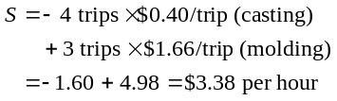
3. Because the net savings for the new layout is small, other factors should be considered before a final decision is made. For example, the cost of changing from the old layout to the new layout could completely eliminate the advantages of operating the new layout. In addition, there may be other factors, some noneconomic, that were not discussed in the case that could cause you to want to stay with the old layout. In general, when the cost savings of a new approach, a new layout in this case, is small, careful analysis should be made of other factors.
2
THE WINTER PARK HOTEL
1. The current system has five clerks each with his or her own waiting line. This can be treated as five independent queues, each with an arrival time of λ = 90/5 = 18 per hour. The service rate is one every three minutes or μ = 20 per hour. Assuming Poisson arrivals and exponential service times, the average amount of time that a guest spends waiting and checking-in is given by:
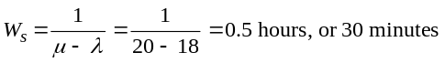
If 30 percent of the arrivals (that is, λ = 0.3 × 90 = 27 per hour) are diverted to a quick-serve clerk who can register them in an average of two minutes (μ = 30 per hour), their average time in the system will be 20 minutes. The remaining 63 arrivals per hour would distribute themselves equally among the four remaining clerks (λ = 63/4 = 15.75 per hour), each of whose mean service time is 3.4 minutes (or 0.5667 hours), so that μ = 1/0.5667 = 17.65 per hour. The average time in the system for these guests will be 0.53 hours or 31.8 minutes. The average time for all arrivals would be 0.3 × 20 + 0.7 × 31.8 = 28.3 minutes.
A single waiting line for the five clerks yields an M/M/5 queue with λ = 90 per hour, μ = 20 per hour. The calculation of average time in system gives Ws = 7.6 minutes. This plan is clearly faster.
Use of an ATM with the same service rate as the clerks (20 per hour) by 20 percent of the arrivals (18 per hour) gives the same average time for these guests as the current system—30 minutes. The remaining λ = 72 per hour form an M/M/4 or M/M/5 queuing system. With four servers, the average time in the system is 8.9 minutes, resulting in an overall average of:
0.2 × 30 + 0.8 × 8.9 = 13.1 minutes
With five servers, the average time is 3.9 minutes resulting in an overall average of:
0.2 × 30 + 0.8 × 3.9 = 9.1 minutes
2. Therefore, the single waiting line with five clerks is the better option.

Additional Case Study*
PANTRY SHOPPER
Beth wants to get a general idea of the system behavior. She first will need to decide whether she is interested in time waiting or time in system. Some students may use system time, but because most shoppers are relieved when it is their turn, we use waiting time as our measure. For all of our analyses, we use current service times, even though a UPC reader is going to be installed. This means that our waiting times are an upper bound for the new, better system. We also assume the M/M/S model.
We begin with a rough analysis (one that is going to have a very interesting feature, by the way). We assume that there are no express lanes. Then, we want to find the average service time and rate. The time is given by:
t = 0.2 (2 minutes) + 0.8 (4 minutes) = 0.4 + 3.2 = 3.6 minutes
This means that the average service rate is 60/3.6 = 16.67 customers per hour. Notice that this is not the same as taking 20 percent of the rate of 30 and 80 percent of the rate of 15, which would equal 18 and would be wrong.

*Solution to case that appears on our Companion Web site,
www.pearsonglobaleditions.com/heizer.
Using an arrival rate of 100 and a service rate of 16.67, the minimum number of servers is 6. (This is due to round off.) In reality, the minimum number is 7, and the average waiting time is 2.2 minutes. Trying one more server leads to a waiting time of 0.64 minutes.
Now we separate the express and regular customers. Assume that all express customers go into the express lane (even though they can go into any lane) and assume that all nonexpress customers go into the proper lanes (even though we all have seen people with 20 packages get into a 10-items-or-less line).
For the express lane, with an arrival rate of 20 and a service rate of 30, one server yields an average wait of 4 minutes, while two servers yield an average wait of 0.25 minutes.
For the regular lane, with an arrival rate of 80 and a service rate of 15, 6 servers yield an average wait of 4.28 minutes, and 7 servers yield an average wait of 0.98 minutes.
If Beth uses 7 servers, they will be split this way: 6 in regular lanes and 1 in an express lane. If Beth uses 8 servers, a 6–2 split between regular lanes and express lanes yields an average wait of:
(0.2)(0.25) + (0.8)(4.28) = 0.05 + 3.424 = 3.47 minutes
A 7–1 split yields an average wait of:
(0.2)(4) + (0.8)(0.98) = 0.8 + 0.784 = 1.584 minutes
which is better. However, the express lane would be slower than the regular lanes!

